Create And Configure IBM Cloud services

Create IBM Watson IOT Platform and Device

Step-1

Create Internet of Things Platform

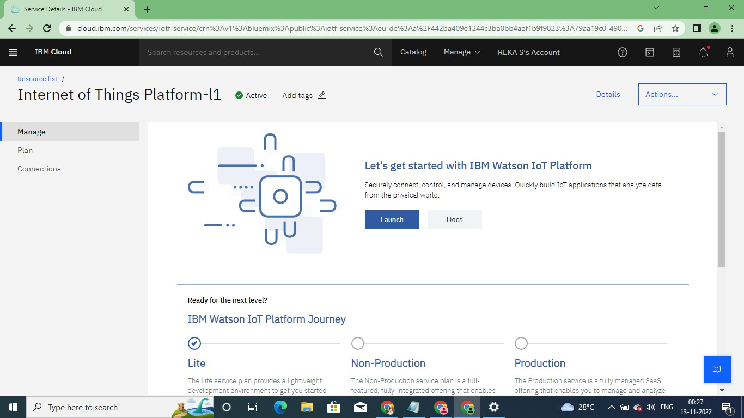

Click on Launch

Next Create IBM Watson IOT Platform

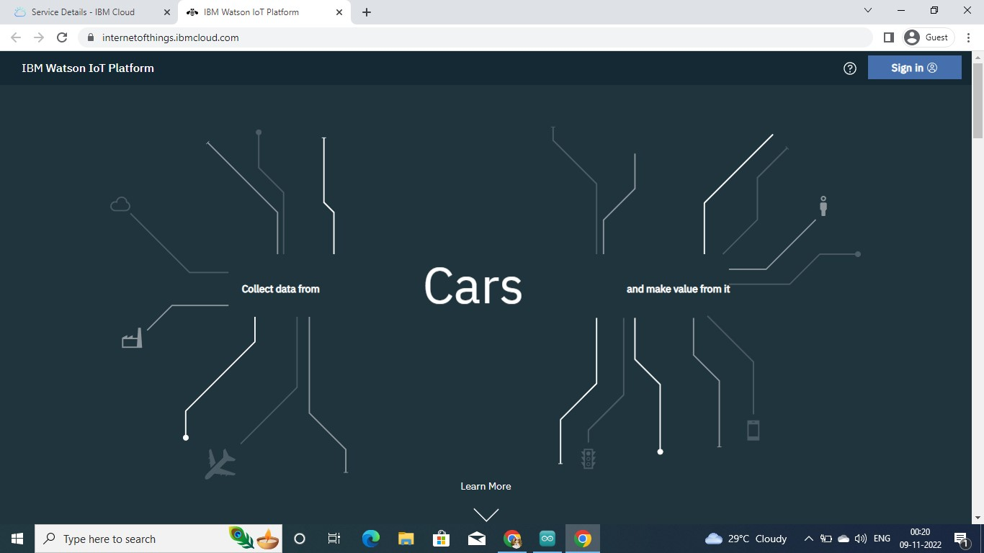

Sign in – IBM Watson IOT Platform

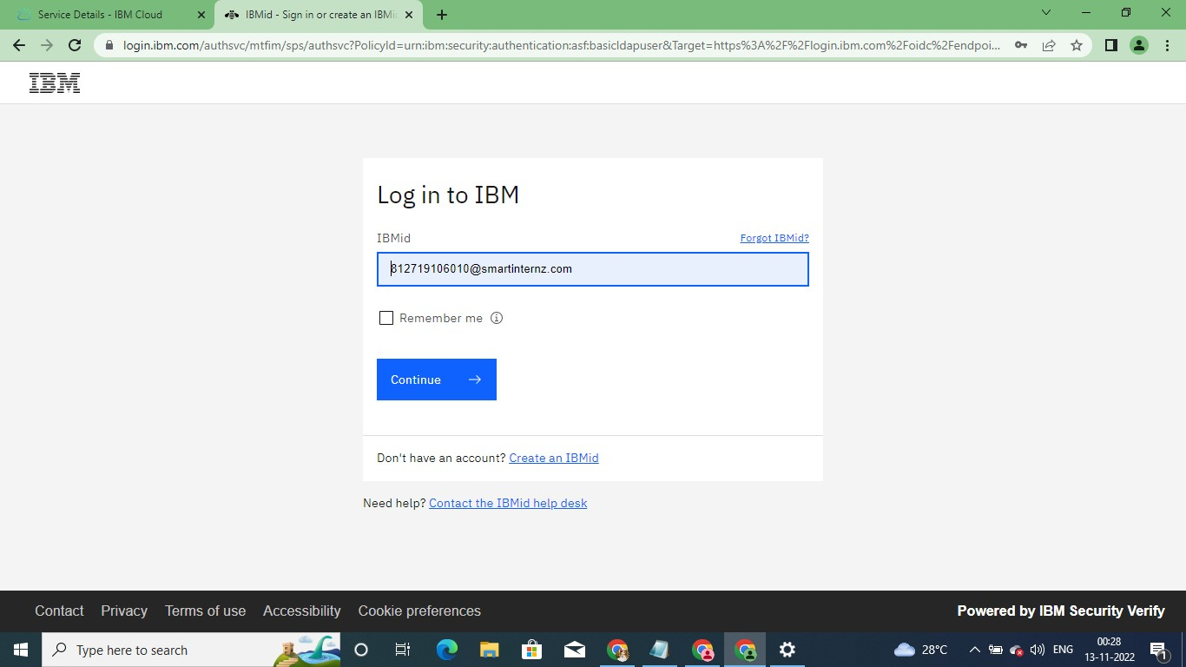

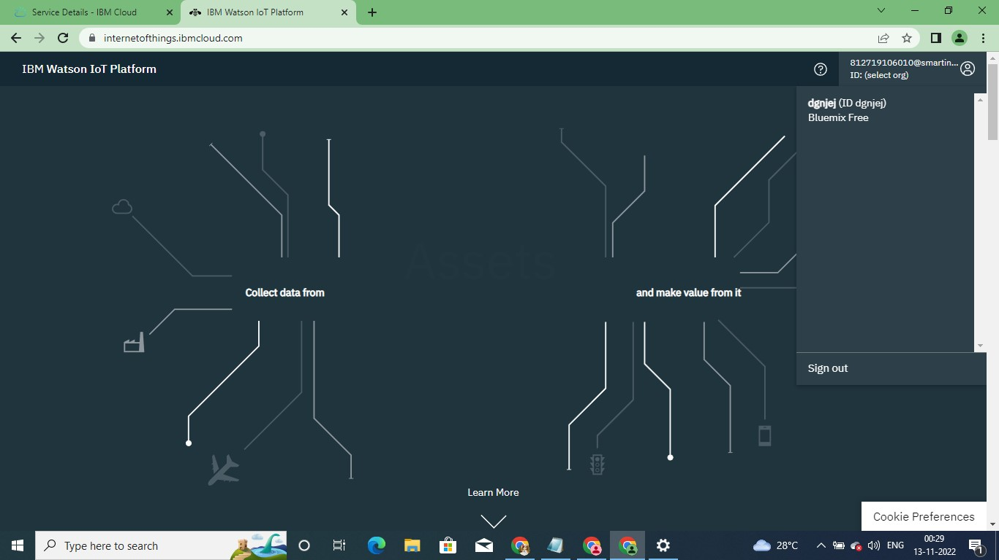

Once sign in IBM Watson IOT Platform

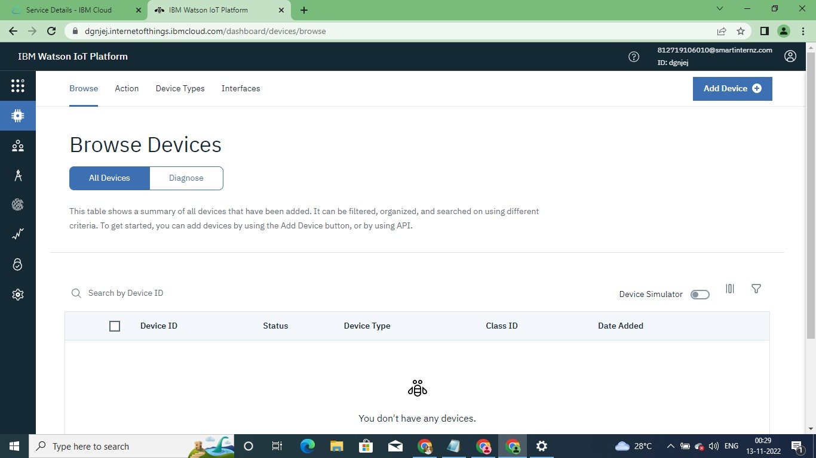

Create advance in the IBM Watson IoT Platform

